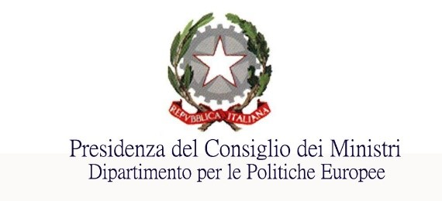
- Dipartimento per le Politiche Europee
Ufficio per il mercato interno, la concorrenza e gli affari generali

Servizio per la libera circolazione delle persone, dei servizi, delle merci e dei capitali
Centro assistenza per il riconoscimento delle qualifiche professionali
centroassistenzaqualifiche@politicheeuropee.it

Request form for information related to the recognition of professional qualifications
The form is aimed at those who intend to pursue a profession in a country other than that in which they acquired their professional qualification (evidence of formal qualifications, attestation of competence and/or professional experience).
For detailed information on the service offered by the Assistance Centre click here
A: Applicant’s personal details
First name:_________________________________________________________________
Surname:__________________________________________________________________Home Country:________________________________________________________
if a company, please specify:
Name of the company:______________________________________________________________ country in which the registered office is located:_________________________________________
If you have any questions, please provide your telephone number________________________________ and email address_______________________________________________________________________
- Information on the profession for which you have qualified
Profession practised in the country of origin:_________________________________________________ Country in which you wish to practise the profession:__________________________________________
Evidence of formal qualification:__________________________________________________________
______________________________________________________________________________________ Country which issued the qualification:______________________________________________________
Number of years practising the profession:______________________
- Subject of the request for assistance
For information on the status of the application for recognition that has been submitted, please contact the competent authority. For the list of competent authorities click here

Select from the list the information that can be requested from the Assistance Centre:
Which is the competent authority for recognising professional qualifications held.

What is the procedure for obtaining recognition of professional qualifications.

Which is the competent authority for the temporary and occasional exercise of the profession.
What is the procedure to be followed for practising the profession temporarily and occasionally.

How can I obtain the European Professional Card – EPC? I am a:

pharmacist ☐ - nurse ☐ - physioterapist ☐ - estate agent ☐ - mountain guide ☐
Which authority is competent for issuing specific certificates required by the host country* (e.g. certification of conformity, certificate of good standing)

* Country in which the applicant intends to practise the profession, other than the country of origin

Other:

_____________________________________________________________________________________
_____________________________________________________________________________________
_____________________________________________________________________________________

- Please explain the reasons for the request:
__________________________________________________________________________
__________________________________________________________________________
__________________________________________________________________________

RESPONSE TIMES
The Assistance Centre shall reply only to requests sent via this form within 30 working days of receipt of this form, which must be sent by email to the following address:
centroassistenzaqualifiche@politicheeuropee.it
Should any additions or clarifications be needed or the request be particularly complex and require further investigation, the Centre will issue a new deadline within 15 days of receipt of the request.

I hereby authorise the processing of personal data present pursuant to Legislative Decree No 196 of 30 June 2003 ‘Personal Data Protection Code’ and Regulation (EU) 2016/679 and have been informed that it will be processed, including by electronic means, exclusively in the context of the procedure for which this declaration is made.

